Reasonable Care

(HealthCare Management System)

CSC 540 Database Management Concepts and Systems

Project Report #2

Project Team

Amit Borulkar aborulk@ncsu.edu
Pushpendra Gupta pgupta6@ncsu.edu
Satvik Andi sandi@ncsu.edu
Yogesh Birla ydbirla@ncsu.edu

Assumptions

- We do not auto generate ids for insurance and vaccines.
- The student status will be changed to HOLD if he does not take the required 3 vaccines. The other departments will directly check the student record to see if the student status is active or not.
- The first physical check-up for a student is the always the free one.
- When a student calls the receptionist, (s)he uses the same application interface for booking as the student.
- Only the doctor is responsible for all medication. Nurses only advise.
- The charges that the insurance is liable to cover are only the consultation charges. The cost of medicines has to be taken care of by the student.
- The co-payment amount is the amount that the student has to pay from the total bill (20%). The rest of the bill (80%) is directly billed to the insurance when the appointment is confirmed.
- When a student has paid the minimum deductible then he does not have to pay even the co-payment.
- The appointment duration will be fixed (20 minutes only).
- Student already has student ID given by the university before they access the system. Student ID will be the login ID and student Date of Birth will be the default password for students.
- Availability Entity set contains information about the availability of employees. This entity set is populated by the HR department that handles the employee shifts and leaves. Our system will only access it for checking the availability (Read Only table).
1) Database Schema

Relational Schemas:
- Student(studentId, sName, SSN, DOB, email, phone, status)

studentId -> sName,SSN,DOB,email,phone,status

Here student_id is unique identity which determines name,SSN,email_id,date of birth,status of student and phone_no.
The relation is in BCNF and 3NF as on left side we have super key which determines all the attributes of the given relation.
Other dependency doesn’t hold. Like name->SSN because name is not unique for everyone. Same is the case with DOB and Status.While other attributes like phone_no can be NULL so it is not the primary key.

- Employee(employeeId, eName, phoneNo, SSN)

employeeId-> eName,phoneNo,SSN

The relation is in BCNF and 3NF because employee_id is unique identity and it uniquely determines employee name, phone number and SSN.
Phone number can be a NULL field and so it cannot determine the tuple uniquely and name can be same for many employees.

- Receptionist(receptionistId)
receptionistId -> receptionistId

Here receptionistId is a reference key to employeeId of the employee table. The relation is in BCNF and 3NF as receptionistId uniquely determines the receptionist here..

- Doctor(doctorId, harges, specialization)

doctorId-> charges, specialization

Here doctorId is a reference key to employeeId of the employee table. The relation is in BCNF and 3NF as doctorId uniquely determines charges and specialization. Charges cannot be the primary key as two doctor can charge same cost and can have same specialization.

- Nurse(nurseId)

nurseId-> nurseId
Here nurseId is a reference key to employeeId of the employee table.The relation is in BCNF and 3NF as nurseId uniquely determines the nurse here.

- Insurance(insuranceId, iName, deductibleAmount)
insuranceId -> iName,deductibleAmount

The relation is in BCNF and 3NF as insuranceId uniquely determines the insurance name of the student and deductible amount for that insurance.

Here deductible amount can be zero or same for different insurances so it won’t be a primary key and insurance name can also be nearly same so making it a primary key will create a confusion.

- Vaccines(vaccineId, vName, requirements)

vaccineId -> vName, requirements

The relation is in BCNF and 3NF as vaccineid uniquely determines the vaccine name and if its one of the required vaccines.

- Appointment(appointmentId, studentId, employeeId, appointmentDate, startTime, studentPaid, insurancePaid, purpose, Notes)

appointmentId -> appointmentDate,startTime,studentPaid ,insurancePaid,purpose,Notes

The relation is in BCNF and 3NF as here appointmentId uniquely determines the appointment Date, startTime, studentPaid and insurance paid amount, purpose of the visit and notes for the visit. Student Id and Employee Id acts here as Foreign key attributes maintaining the integrity constraint for the relation.

Rest of attributes cannot act as a primary key attribute as they can have same values for many tuples and some can be NULL.

- Has(studentId, insuranceId, amountPaid, expiresOn)

studentId -> amountPaid,expiresOn
The relation is in BCNF and 3NF as here studentId uniquely determines when his insurance expires and amount Paid for the insurance.
Here insuranceId acts as a foreign key referencing Insurance Table.

- Availability(employeeID, mon, tue, wed, thr, fri, sat, sun)
employeeId -> mon, tue, wed, thr, fri, sat, sun

The relation is in BCNF and 3NF as here employeeId uniquely determines availability on mondays, tuesdays, wednesdays, thursdays,fridays,saturdays and Sundays.

- Calls(CID, studentId, employeeId, currentDate, consultation)
cid -> currentDate, consultation

The relation is in BCNF and 3NF as here cid determines date of call and consultation given on the call. StudentId and EmployeeId are reference keys for the student table and employee table.

- Takes (TID, studentId, vaccineId, currentDate)
TID-> currentDate

The relation is in BCNF and 3NF as here tid determines date of vaccine taken. studentId and vaccineId are reference keys for the student and vaccine table maintaining the integrity constraint.

- Login(loginId, password, designation)
loginId -> password,designation
The relation is in BCNF and 3NF as here loginId uniquely determines password and designation of the person

2) Design Decisions

In order to create the Global schemas, we mechanically converted each entity into a relational schema with corresponding attributes. Relationships were also represented by a relation whose attributes are the keys for the connected entity sets along with specific attributes that the relationship itself has.

Receptionist, Doctor and Nurse follow an IS-A relationship with the Employee entity. E-R approach is used to design the relational schemas of these entities.

The following are the constraints on the attributes of the relations of Global Schema:

1. Student (studentId, SName, SSN, DOB, email, phone, status)

studentId - Primary Key - Every student can be uniquely identified by their student id.
sName - NOT NULL - Every student definitely has a name.
SSN - NULL - Not all students need to have an SSN. A null value for an SSN field means that the student is not working and does not have an SSN.
DOB - NOT NULL - Date of Birth is going to be the default password for student login.
email - NULL - Student record can be created without a student's email id.
phone - NULL - A student may or may not have a contact phone number.
status - NOT NULL -By default, it's value is set to active. It may change to not active. But it always holds a value and is never NULL.
2. Employee (employeeId,eName,phoneNo,SSN)

employeeId - PRIMARY KEY - Every employee can be uniquely identified using their employee id.
ename - NOT NULL - Every employee has a name.
phoneNo - NULL - An employee record can be created without contact phone number. It is updated by the employee later.
SSN - NOT NULL - Every employee has an SSN.
3. Receptionist (receptionistId)
receptionistId - Referential Integrity Constraint ( Foreign Key) - receptionistId refers to employeeId, which is the primary key of Employee entity.

4. Doctor (doctorId,charges,specialization)
doctorId - Referential Integrity Constraint ( Foreign Key) - doctorId refers to employeeId, which is the primary key of Employee entity.
charges - NOT NULL - Every doctor charges a certain fee per visit.
specialization - NULL - Not all doctors have a specialization. A null value here means that a doctor is a general physician.
5. Nurse (nurseId)
nurseId - Referential Integrity Constraint ( Foreign Key) - nurseId refers to employeeID which is the primary key of Employee entity.
6. Insurance(insuranceId,iName,deductibleAmount)
insuranceId - PRIMARY KEY - Uniquely identifies insurance name and details.
iname - NOT NULL - Every insurance policy has a name.
deductibleAmount - NOT NULL - There will be some amount or 0 but there will always be a value. A NULL value will affect our calculation of amount paid.

7. Vaccines(vaccineId,vName,requirements)
vaccineId - PRIMARY KEY - Every vaccine is uniquely identified by it's id.
vName - NOT NULL - Every vaccine has a name.
requirements - NULL - A NULL value here means that a particular vaccine has no pre-requirements.

8. Appointment(appointmentId,studentId,employeeId,appointmentDate,startTime, studentPaid ,insurancePaid,purpose,Notes)

appointmentId - PRIMARY KEY - Every appointment can be uniquely identified by it's ID.
studentId - (Referential Constraint - FOREIGN KEY) - studentId is the primary key of Student entity.
employeeId - (Referential Constraint - FOREIGN KEY) - employeeId is the primary key of Employee entity.
appointmentDate - NOT NULL - every appointment is booked for a certain date.
startTime - NOT NULL - every booked appointment has a fixed start time.
studentPaid - NULL - NULL value means that the insurance company has paid for the whole appointment expense.
insurancePaid - NULL - NULL value here means that the amount incurred for a treatment doesn't come under the insurance coverage policy and hence is completely paid by the student.

purpose - NOT NULL - Every appointment is for a specific medical purpose

Notes - NULL - The doctor may or may not make any notes after a check up.

9. Has(studentId, insuranceId, amountPaid, expiresOn)

studentId - PRIMARY KEY - determines the student whose insurance details we are looking at.
insuranceId – NOT NULL – Every student must have an insurance. By default, every
student is registered to ACME health insurance.
amountPaid - NOT NULL - Every student necessarily pays some amount to buy the insurance.
expiresOn - NOT NULL - Every insurance has an expiry date.

10. Availability(employeeID,mon,tue,wed,thr,fri,sat,sun)

employeeId - PRIMARY KEY - determines the id of the employee we are checking the availability of.
Mon - NULL - Null value means that the employee is on leave on Monday.
Tue - NULL - Null value means that the employee is on leave on Tuesday.
Wed - NULL - Null value means that the employee is on leave on Wednesday.
Thr - NULL - Null value means that the employee is on leave on Thursday.
Fri - NULL - Null value means that the employee is on leave on Friday.
Sat - NULL - Null value means that the employee is on leave on Saturday.
Sun - NULL - Null value means that the employee is on leave on Sunday.

11. CALLS(CID, studentId, employeeId, currentDate, consultation)
CID - PRIMARY KEY - Uniquely identifies the record of a particular call.
Studentid - (Referential Constraint - FOREIGN KEY) - student_id is the primary key of Student entity.
Employeeid - (Referential Constraint - FOREIGN KEY) - employee_id is the primary key of Employee entity.
currentDate - NOT NULL - Every call has a date when the call is made.
Consultation – NULL – There might be cases where no relavant information is
documented.

12. Takes (tid, studentid, vaccineid, currentdate)
tid - PRIMARY KEY - because 1 student can take the same vaccine many times and hence every time he takes a vaccine, it should be uniquely identified.
studentid - Referential Integrity Constraint (Foreign Key) - student_id is the primary key of Student entity.
vaccineid - Referential Integrity Constraint (Foreign Key) - vaccine_id is the primary key of Vaccine entity.
currentdate - NOT NULL - There should be a date when a vaccine is administered.

13. LOGIN (loginId,password,designation)
loginId - PRIMARY KEY - Every user has a unique Login Id.
password - NOT NULL - All users have a default password even if not reset.
designation - NOT NULL – Every designated person is only allowed to login.

3) SQL Statements

Drop Table // Find about not null columns

DROP TABLE APPOINTMENT CASCADE CONSTRAINTS;
DROP TABLE HAS CASCADE CONSTRAINTS;
DROP TABLE TAKES CASCADE CONSTRAINTS;
DROP TABLE AVAILABILITY CASCADE CONSTRAINTS;
DROP TABLE CALLS CASCADE CONSTRAINTS;
DROP TABLE STUDENT CASCADE CONSTRAINTS;
DROP TABLE EMPLOYEE CASCADE CONSTRAINTS;
DROP TABLE DOCTOR CASCADE CONSTRAINTS;
DROP TABLE RECEPTIONIST CASCADE CONSTRAINTS;
DROP TABLE NURSE CASCADE CONSTRAINTS;
DROP TABLE INSURANCE CASCADE CONSTRAINTS;
DROP TABLE VACCINES CASCADE CONSTRAINTS;
DROP TABLE LOGIN CASCADE CONSTRAINTS;

Drop Sequence

DROP SEQUENCE StudentID;
DROP SEQUENCE EmployeeID;
DROP SEQUENCE AppointmentID;
DROP SEQUENCE CID;
DROP SEQUENCE TID;
DROP SEQUENCE HID;

Create Tables

CREATE TABLE EMPLOYEE(
EmployeeID number(10) Primary Key,
EName varchar(30) NOT NULL,
SSN number(20) NOT NULL,
Phone number(10)
);

CREATE TABLE STUDENT(
StudentID number(10) Primary Key,
SSN varchar(30),
SName varchar(50) NOT NULL,
DOB date NOT NULL,
Email varchar(20),
Phone number(10),
Status varchar(10) DEFAULT ‘ACTIVE’
);

CREATE TABLE DOCTOR(
DoctorID number(10) PRIMARY KEY,
Specialization varchar(50),
charges number(10) NOT NULL,
CONSTRAINT doctor_fk FOREIGN KEY(DoctorID) REFERENCES Employee(EmployeeID) ON DELETE CASCADE
);

CREATE TABLE RECEPTIONIST(
ReceptionistID number(10) PRIMARY KEY,
CONSTRAINT receptionist_fk FOREIGN KEY(ReceptionistID) REFERENCES Employee(EmployeeID) ON DELETE CASCADE
);

CREATE TABLE NURSE(
NurseID number(10) PRIMARY KEY,
CONSTRAINT nurse_fk FOREIGN KEY(NurseID) REFERENCES Employee(EmployeeID)
ON DELETE CASCADE
);

CREATE TABLE INSURANCE(
InsuranceID varchar(10) Primary Key,
IName varchar(20) NOT NULL,
DeductibleAmount number (10) NOT NULL
);

CREATE TABLE VACCINES(
VaccineID varchar(10) Primary KEY,
VName varchar(50) NOT NULL,
Requirements varchar(50)
);

CREATE TABLE APPOINTMENT(
AppointmentID number(10) Primary Key,
StudentID number(10),
EmployeeID number(10),
AppointmentDate date,
StartTime timestamp,
StudentPaid number(10),
InsurancePaid number(10),
Purpose varchar(100),
Notes varchar(500),
CONSTRAINT student_appointment_fk FOREIGN KEY(StudentID) REFERENCES Student(StudentID)ON DELETE CASCADE,
CONSTRAINT employee_appointment_fk FOREIGN KEY(EmployeeID) REFERENCES Employee(EmployeeID)ON DELETE CASCADE
);

CREATE TABLE HAS(
StudentID number(10) PRIMARY KEY,
InsuranceID varchar(10),
AmountPaid number(10) DEFAULT 0,
ExpiresOn Date,
CONSTRAINT has_fk FOREIGN KEY(InsuranceID) REFERENCES Insurance(InsuranceID) ON DELETE CASCADE
);

CREATE TABLE AVAILABILITY(
EmployeeID number(10) Primary Key,
Mon varchar(20),
Tue varchar(20),
Wed varchar(20),
Thr varchar(20),
Fri varchar(20),
Sat varchar(20),
Sun varchar(20)
);

CREATE TABLE CALLS(
CID number(10) Primary Key,
StudentID number(10),
EmployeeID number(10),
CurrentDate Date,
Consultation varchar(500),
CONSTRAINT student_calls_fk FOREIGN KEY(StudentID) REFERENCES Student(StudentID)ON DELETE CASCADE,
CONSTRAINT employee_calls_fk FOREIGN KEY(EmployeeID) REFERENCES Employee(EmployeeID)ON DELETE CASCADE
);

CREATE TABLE TAKES(
TID number(10) PRIMARY KEY,
StudentID number(10),
VaccineID varchar(10),
CurrentDate Date NOT NULL,
CONSTRAINT student_takes_fk FOREIGN KEY(StudentID) REFERENCES Student(StudentID)ON DELETE CASCADE,
CONSTRAINT vaccine_takes_fk FOREIGN KEY(VaccineID) REFERENCES Vaccines(VaccineID)ON DELETE CASCADE
);

CREATE TABLE LOGIN(
LoginID number(10) Primary Key,
password varchar(50) NOT NULL,
designation varchar(20) NOT NULL
);

Sequence

CREATE SEQUENCE StudentID START WITH 1 INCREMENT BY 1;
CREATE SEQUENCE EmployeeID START WITH 100000 INCREMENT BY 1;
CREATE SEQUENCE AppointmentID START WITH 1 INCREMENT BY 1;
CREATE SEQUENCE CID START WITH 1 INCREMENT BY 1;
CREATE SEQUENCE TID START WITH 1 INCREMENT BY 1;
CREATE SEQUENCE HID START WITH 1 INCREMENT BY 1;

Inserts

EMPLOYEE
INSERT INTO Employee(employeeId, ename, SSN, phone) values (EmployeeID.nextval,'Miss Aliya(N)',1112223334,9193493860);

INSERT INTO Employee(employeeId, ename, SSN, phone) values (EmployeeID.nextval,'Miss Mansi(N)',1112223634,9193435860);

INSERT INTO Employee(employeeId, ename, SSN, phone) values (EmployeeID.nextval,'Miss Janet(R)',1112223335,9193493861);

INSERT INTO Employee(employeeId, ename, SSN, phone) values (EmployeeID.nextval,'Miss Joann(R)',1112223335,9193493861);

INSERT INTO Employee(employeeId, ename, SSN, phone) values (EmployeeID.nextval,'Dr. Mark',1112823336,9193493862);

INSERT INTO Employee(employeeId, ename, SSN, phone) values (EmployeeID.nextval,'Dr. Micheal',1112222337,9193493863);

INSERT INTO Employee(employeeId, ename, SSN, phone) values (EmployeeID.nextval,'Dr. Matt',1112293338,9193493864);

INSERT INTO Employee (employeeId, ename, SSN, phone) values (EmployeeID.nextval,'Dr. Anderson',1111223453,9193653862);

INSERT INTO Employee (employeeId, ename, SSN, phone) values (EmployeeID.nextval,'Dr. Chauhan',1111223453,9193653862);

DOCTOR
INSERT INTO Doctor(DoctorId, specialization, charges) VALUES
(100004,'Heart',50);

INSERT INTO Doctor(DoctorId, specialization, charges) VALUES
(100005,'Legs',40);

INSERT INTO Doctor(DoctorId, specialization, charges) VALUES
(100006,'Surgeons',60);

INSERT INTO Doctor(DoctorId, specialization, charges) VALUES
(100007,'Surgeons',60);

INSERT INTO Doctor(DoctorId, specialization, charges) VALUES
(100008,'General Physicain',60);

RECPTIONIST
INSERT INTO Receptionist(Receptionistid) VALUES (100002);
INSERT INTO Receptionist(Receptionistid) VALUES (100003);

NURSE
INSERT INTO Nurse(NurseId) VALUES (100000);
INSERT INTO Nurse(NurseId) VALUES (100001);

STUDENT
INSERT INTO STUDENT(StudentID, SSN, Sname, DOB, Email, Phone, status)VALUES
(StudentID.nextval, ‘2122122121’,’Amit’, '10-OCT-92','aborulk@ncsu.edu',9193493729,’N');

INSERT INTO STUDENT(StudentID, SSN, Sname, DOB, Email, Phone, status)VALUES (StudentID.nextval,'2122122122','Arjun','10-OCT-92','arjungupta@ncsu.edu',9193493728,'N');

INSERT INTO STUDENT(StudentID, SSN, Sname, DOB, Email, Phone, status) values(StudentID.nextval,'2122122123','Yogesh','10-OCT-92','yogeshbirla@ncsu.edu',9193493727,'N');

INSERT INTO STUDENT(StudentID, SSN, Sname, DOB, Email, Phone, status) values(StudentID.nextval,'2122122124','Satvik','10-OCT-92','satvikandi@ncsu.edu',9193493726,'N');

INSERT INTO STUDENT(StudentID, SSN, Sname, DOB, Email, Phone, status)VALUES
(StudentID.nextval,'2122122125','Priyanka','10-OCT-92','pchopra@ncsu.edu','9193493725','N');
INSURANCE
INSERT INTO INSURANCE(InsuranceID,Iname, DeductibleAmount) VALUES ('I1000','LIC',80);

INSERT INTO INSURANCE(InsuranceID,Iname, DeductibleAmount) VALUES ('I1001','ICICI',80);

INSERT INTO INSURANCE(InsuranceID,Iname, DeductibleAmount) VALUES ('I1002','ISO',80);

INSERT INTO INSURANCE(InsuranceID,Iname, DeductibleAmount) VALUES
('I1003','Blue cross',80);

INSERT INTO INSURANCE(InsuranceID,Iname, DeductibleAmount) VALUES ('I1004','ACME',20);

HAS
INSERT INTO HAS(StudentID,InsuranceID,AmountPaid,ExpiresOn) Values (1,'I1001',80,'10-OCT-92');

INSERT INTO HAS(StudentID,InsuranceID,AmountPaid,ExpiresOn) values (2,'I1004',20,'10-OCT-92');

INSERT INTO HAS(StudentID,InsuranceID,AmountPaid,ExpiresOn) Values (3,'I1004',20,'10-OCT-92');

INSERT INTO HAS(StudentID,InsuranceID,AmountPaid,ExpiresOn) values (4,'I1002',80,'10-OCT-92');

INSERT INTO HAS(StudentID,InsuranceID,AmountPaid,ExpiresOn) Values (5,'I1003’,80,'10-OCT-92');

VACCINES
INSERT INTO VACCINES(VaccineID, Vname, Requirements) values (‘V1500','HepatatisA','Needs Doctor prescription');

INSERT INTO VACCINES(VaccineID, Vname, Requirements) values ('V1501','Tetanus','Age must be 18+');

INSERT INTO VACCINES(VaccineID, Vname, Requirements) values ('V1502','HepatatisB','Needs Doctor prescription');

INSERT INTO VACCINES(VaccineID, Vname, Requirements) values ('V1503','Polio','Age between 0 to 5');

INSERT INTO VACCINES(VaccineID, Vname, Requirements) values ('V1504','HepatatisC','Needs Doctor prescription');

TAKES
INSERT INTO Takes(TID, studentID, vaccineID, currentdate) values (TID.nextval,'1','V1500','10-OCT-92');

INSERT INTO Takes(TID, studentID, vaccineID, currentdate) values (TID.nextval,'2','V1500','10-OCT-92');

INSERT INTO Takes(TID, studentID, vaccineID, currentdate) values (TID.nextval,'1','V1501','10-OCT-92');

INSERT INTO Takes(TID, studentID, vaccineID, currentdate) values (TID.nextval,'3','V1504','10-OCT-92');

INSERT INTO Takes(TID, studentID, vaccineID, currentdate) values (TID.nextval,'2','V1502','10-OCT-92');

Appointment
INSERT INTO APPOINTMENT(AppointmentID, StudentID, EmployeeID, AppointmentDate, StartTime, StudentPaid, InsurancePaid, Purpose, Notes) values (AppointmentID.nextval,3,100004,'03-MAR-14','03-MAR-14 08:40:00',20,80,'Heart','Plaster');

INSERT INTO APPOINTMENT(AppointmentID, StudentID, EmployeeID, AppointmentDate, StartTime, StudentPaid, InsurancePaid, Purpose, Notes) values (AppointmentID.nextval,4,100005,'03-MAR-14','03-MAR-14 09:00:00',20,80,'Leg','Clips');

INSERT INTO APPOINTMENT(AppointmentID, StudentID, EmployeeID, AppointmentDate, StartTime, StudentPaid, InsurancePaid, Purpose, Notes) values (AppointmentID.nextval, 5,100006,'03-MAR-14','03-MAR-14 09:20:00',20,80,'Surgury','Organ Replaced');

INSERT INTO APPOINTMENT(AppointmentID, StudentID, EmployeeID, AppointmentDate, StartTime, StudentPaid, InsurancePaid, Purpose, Notes) values (AppointmentID.nextval, 5,100007,'04-MAR-14','04-MAR-14 09:20:00',20,80,'Surgury','Organ Replaced');

INSERT INTO APPOINTMENT(AppointmentID, StudentID, EmployeeID, AppointmentDate, StartTime, StudentPaid, InsurancePaid, Purpose, Notes) values (AppointmentID.nextval, 1,100007,'04-MAR-14','04-MAR-14 10:00:00',20,80,'Surgury',’Root canal’);

INSERT INTO APPOINTMENT(AppointmentID, StudentID, EmployeeID, AppointmentDate, StartTime, StudentPaid, InsurancePaid, Purpose, Notes) values (AppointmentID.nextval, 1,100004,'05-MAR-14','05-MAR-14 10:00:00',20,80, ’Cardio check’,’Perform some blood test’);

INSERT INTO APPOINTMENT(AppointmentID, StudentID, EmployeeID, AppointmentDate, StartTime, StudentPaid, InsurancePaid, Purpose, Notes) values (AppointmentID.nextval, 2,100008,'05-MAR-14','05-MAR-14 10:20:00',20,80,'General Checkup',’Need blood test’);

CALLS
INSERT INTO CALLS(CID,StudentId,EmployeeId,currentDate) values
(CID.nextval, 1, 100002, '05-MAR-14’,’Make an appointment’);

INSERT INTO CALLS(CID,StudentId,EmployeeId,currentDate) values
(CID.nextval, 2, 100002, '05-MAR-14’,’Fever and headache’);

INSERT INTO CALLS(CID,StudentId,EmployeeId,currentDate) values
(CID.nextval, 1, 100003, '05-MAR-14’,’Vomitting’);

INSERT INTO CALLS(CID,StudentId,EmployeeId,currentDate) values
(CID.nextval, 1, 100001, '05-MAR-14’,’Go to specialist’);

INSERT INTO CALLS(CID,StudentId,EmployeeId,currentDate) values
(CID.nextval, 3, 100002, '05-MAR-14’,’Cannot reach doctor’);

AVAILABILITY
INSERT INTO AVAILABILITY (EmployeeID, Mon, Tue, Wed, Thr, Fri) VALUES (100004,'8:30-14:30', '8:30-14:30', '8:30-12:30', '8:30-11:30', '8:30-11:30');

INSERT INTO AVAILABILITY (EmployeeID, Mon, Tue, Sat, Sun ) VALUES (100005,'13:30-15:30','13:30-15:30', '7:30-11:30', '7:30-11:30');

INSERT INTO AVAILABILITY (EmployeeID, Wed, Thr, Fri) VALUES (100006,'10:30-14:30', '8:30-14:30', '8:30-12:30');

INSERT INTO AVAILABILITY (EmployeeID, Mon, Tue, Wed, Thr, Fri) VALUES (100007,'8:30-14:30', '8:30-14:30', '8:30-14:30', '19:30-04:30', '19:30-04:30');

INSERT INTO AVAILABILITY (EmployeeID, Mon, Tue, Wed, Thr, Fri) VALUES (100008,'8:30-17:30', '8:30-17:30', '8:30-17:30', '8:30-17:30', '8:30-17:30');

Select Statements :

Note: Some snapshots are taken in SQL Developer for readability.

Employee :
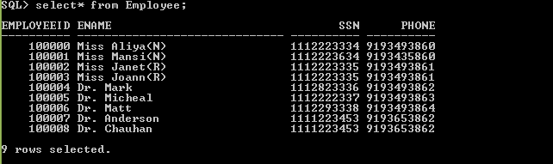

DOCTOR
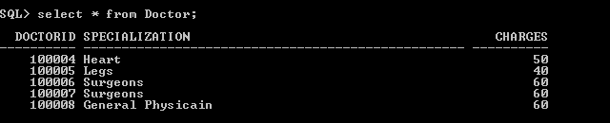

Receptionist:


Nurse:


Student:
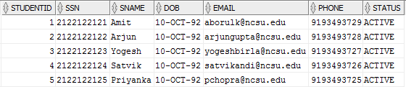

INSURANCE :


Vaccines:
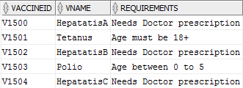
Appointment :
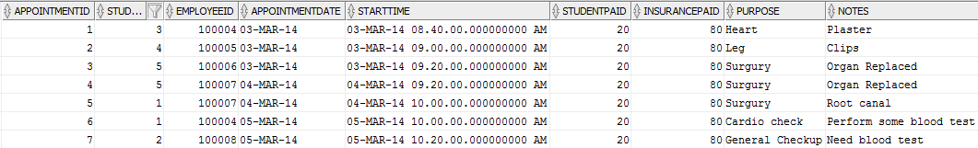

HAS:


Availability:
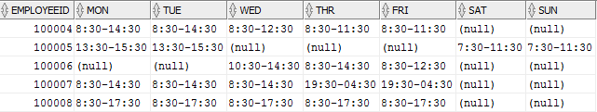

Calls:


Takes:

4) Interactive SQL Queries

Note: Some snapshots are taken in SQL Developer for readability.

4.1 Queries for tasks and operations

2. Manage User Accounts

Register new student (Admin creates student record with mandatory information)
SQL> insert into student(StudentId, SName, DOB) values
(StudentID.nextval,Vishal,’10-OCT-92’);

1 row created.

Take personal Information from Student (By Student);
SQL> update student set SSN='123121212', email='vbirla@ncsu.edu',phone='9195799932' where studentID = 6;

1 row updated.

Create new Health Insurance record (By Admin).
SQL> insert into insurance(InsuranceId,Iname,DeductibleAmount) values ('I1005','Reliance',100);

1 row created.

Create student health insurance information (By Student).
SQL> insert into has(StudentId,InsuranceId,AmountPaid,Expireson) values(6,'I1005',40,'10-OCT-14');

1 row created.

Update student health insurance information (By Student).
SQL> update has set insuranceId='I1001' where studentId=6;

1 row updated.
Create student Login with default password.
SQL> insert into login values(6,'10-OCT-89','Student');

1 row created.

Create doctor Login with default password.
SQL> insert into login values(100004,'10-MAR-69','Doctor');

1 row created.

Create Nurse Login with default password.
SQL> insert into login values(100000,'10-MAR-80','Nurse');

1 row created.

Create Receptionist Login with default password.
SQL> insert into login values(100002,'10-MAR-82','Receptionist');

1 row created.

Update Password.
SQL> update login set password=’newpassword’ where loginid=6;

1 row updated.

Update doctor Specialization and charges
SQL> update doctor set specialization='Cardiologist',charges=99 where doctorId=100004;

1 row updated.

Update doctor availability
SQL> update availability set mon='08:30-13:30',tue=null where employeeid=100004;

1 row updated.

View Appointment (Student View)
SQL> select AppointmentDate,ENAME as Doctor_Name,StartTime
from Student,Doctor,Appointment,Employee
where Student.studentId = Appointment.StudentId
and Appointment.EmployeeId = Doctor.DoctorId
and Doctor.DoctorId = Employee.EmployeeId
and Appointment.studentId= 1;

View Appointments (Doctor View)
SQL> select AppointmentDate,SNAME as Student_Name,StartTime
from Student,Doctor,Appointment,Employee
where Student.studentId = Appointment.StudentId
and Appointment.EmployeeId = Doctor.DoctorId
and doctor.DoctorId = Employee.EmployeeId
and Appointment.EmployeeId= 100004

Check hold status of Students
SQL> select SName,Status from student;

Check student who have taken compulsory vaccines
SQL> select SName from student
where studentid in (
(select studentId from takes where vaccineId='V1500')
INTERSECT
(select studentId from takes where vaccineId='V1501')
);

V1500 and V1501 are compulsory vaccines.

3. Make and Cancel appointment with doctors

Search for Doctors by Specialization
SQL> select EName from Employee,Doctor
where Employee.employeeid = Doctor.doctorId
and specialization like 'Heart Specialist'

Search for Doctor by Reason for Visit
SQL> select EName from Employee,Doctor
where Employee.employeeid = Doctor.doctorId
and specialization like '%Heart%';

Search for doctor’s availability
SQL> Select Ename as Doctor, Specialization, Mon, Tue, Wed,
Thr, Fri, Sat, Sun
from availability,employee,Doctor
where Availability.employeeid in (
select employeeId from Employee,Doctor
where Employee.employeeid = Doctor.doctorId)
and Availability.employeeid = employee.employeeid
and employee.employeeid = doctor.doctorid
Search for Specialist availability
SQL> Select Ename as Doctor, Specialization, Mon, Tue, Wed,
Thr, Fri, Sat, Sun
from availability,employee,Doctor
where Availability.employeeid in (
select employeeId
from Employee,Doctor
where Employee.employeeid = Doctor.doctorId
and specialization like 'Surgeons')
and Availability.employeeid = employee.employeeid
and employee.employeeid = doctor.doctorid

Booking an Appointment
SQL> insert into appointment(AppointmentId,StudentId,
EmployeeId, AppointmentDate, starttime, StudentPaid,
InsurancePaid, purpose) values
(AppointmentId.NEXTVAL,3,100004,'04-MAR-14','04-MAR-14
10:00:00',20,80,'Return visit Checkup');

Updating an Appointment (By Student)
SQL> Update appointment set appointmentdate=’05-MAR-14’,
Starttime=’05-MAR-14 10:20:00’
Where AppointmentId=7;

Updating an Appointment (By Doctor)
SQL> Update appointment set notes=’Require blood test’
Where AppointmentId=7;

View Past Appointments
SQL> select * from appointment where studentId=5 and
APPOINTMENTDATE <= sysdate-1;

Delete an Appointment
SQL> delete from Appointment where appointmentID=7;

Student Vaccine Information
SQL> select SNAME as Student_Name, VName as Vaccines_Takes,
CurrentDate as Taken_On
from Student,takes,Vaccines
where student.studentid = takes.studentid
and takes.vaccineid = vaccines.vaccineid
and student.studentid = 1
4. Handle billing and Co-payments :

Co-payment to be paid by the student for his appointment
SQL> select AppointmentId, AppointmentDate,0.2 * charges as
Amount_Student_Pays
from Doctor,Appointment
where Appointment.Employeeid =
Doctor.doctorid
and studentid =
(Select studentid
from has,insurance
where has.AMOUNTPAID < insurance.deductibleamount
and has.insuranceid = insurance.insuranceid
and has.studentid=5);

Amount Billed to Insurance
SQL> select AppointmentId, AppointmentDate,0.8 * charges as
Amount_Student_Pays
from Doctor,Appointment
where Appointment.Employeeid = Doctor.doctorid
and studentid = 5;

Update Payment information
SQL> update Appointment set studentpaid=20, insurancepaid=80
where appointmentid=7;

4. Staff Interface:

View Medical records/Appointment of student.
SQL> select SName as Student, EName as Doctor, AppointmentDate,
Purpose, Notes from Appointment,
Doctor,Employee,Student
where appointment.studentid = Student.studentid
and appointment.EmployeeId = doctor.doctorid
and doctor.doctorid = Employee.employeeid
and student.studentid = 5

View Vaccines taken by student.
SQL> select VName,CurrentDate as Date_Taken
from Vaccines,takes
where takes.vaccineId = Vaccines.vaccineId
and studentid = 1

Add/Update Notes.
SQL> update appointment set notes=’Need to be tested for
malaria’
where appoinmentid=7;

Add Consulatation.
SQL> INSERT INTO CALLS(CID,StudentId,EmployeeId,currentDate)
values (CID.nextval, 1, 100002, '05-MAR-14’,’Make an
appointment’);

View Past Doctors visited.
SQL> select ENAME as Doctors_Visited, Doctor.SPECIALIZATION,
Employee.PHONE
from Employee, Doctor, Appointment,Student where
Appointment.studentID = Student.StudentID and Appointment.Employeeid = doctor.doctorid
and doctor.doctorid = Employee.EmployeeID
and Student.studentID = 5

4.2 Autotrace and Indexes for two tables

- The first index was added to student based on the "Sname" column.

SQL> SET AUTOTRACE ON;
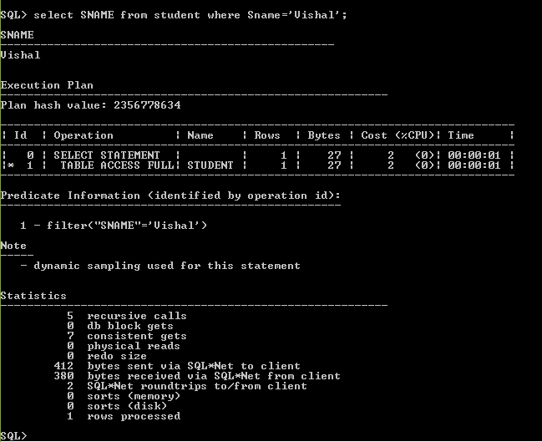

SQL> CREATE INDEX sname_index ON STUDENT(sname);

Index created.

SQL> SELECT sname FROM student WHERE sname='Vishal';

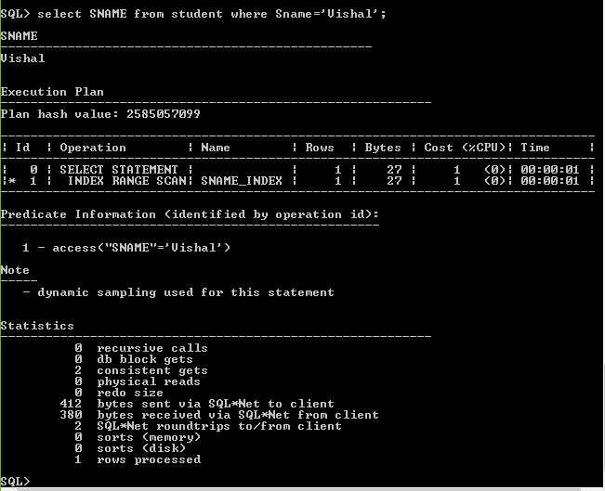

- The second index was added to employee based on the "ename" column.

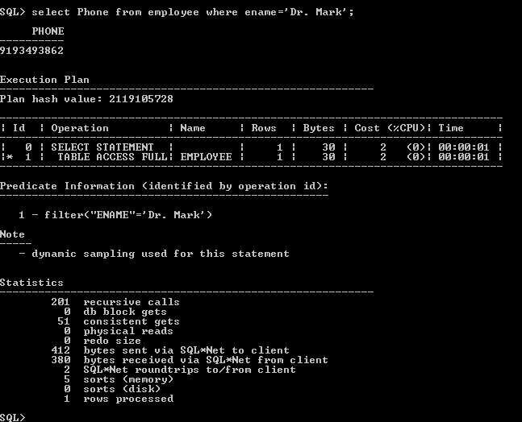

SQL> CREATE INDEX ename_index ON Employee(ename);

Index created.

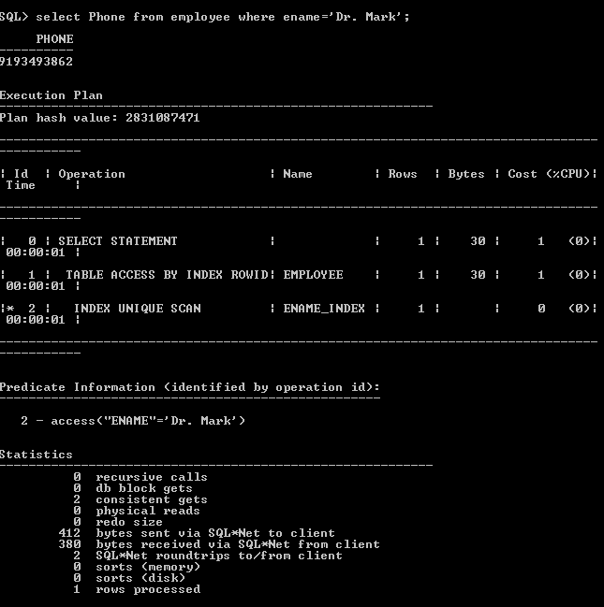

4.3 Query correctness proofs

- Find out the vaccines taken by the student having StudentID = 5.

SELECT v.Vname, t.currentDate as Taken from STUDENT s, Takes t, VACCINE v
WHERE s.studentid = t.StudentId
AND t.vaccineId = v.vaccineID
AND s.StudentId = 5.

a. π _{v.vname, t.currentdate à Taken} ( σ_{(s.StudentID = 5)} (ρs(studentID,SSN, Sname, DOB, Email, Phone, Status) STUDENT wv ρt(StudentId, VaccineId, CurrentDate) TAKES wv ρv(VaccineId, VName, Requirements) VACCINE)))

b. Suppose s is any tuple in the STUDENT relation, t is any tuple in the TAKES relation and v is any tuple in VACCINE relation, such that the value s.studentID is the same as the value t.studentID and the value of t.vaccineID is same as the value of v.vaccineID. Each such combination of tuples (s,t,v) gives all information about the student and the vaccines that they have taken along with the date on which vaccine was given. We perform a selection and select only the tuple where studentId is 5. Since a single student can take many vaccines, we may get multiple tuples for the same studentID. By performing the projection on this result set and renaming the CurrentDate attribute as ‘Taken’, we extract only the vaccine name and the date of vaccine administration which is exactly what our query should return.

2. Find the name and expiry date of the health insurance taken by the student whose studentID is 5.

SELECT i.Iname, h.expireson from Insurance i, Has h, Student s
WHERE s.studentid = h.studentid
AND h.insuranceId = i.insuranceId
AND s.studentId = 5;

a. π _{i.iname, h.expireson} ( σ_{(s.StudentID = 5)} (ρs(studentID,SSN, Sname, DOB, Email, Phone, Status) STUDENT wv ρh(StudentId, insuranceID, AmountPaid, ExpiresOn) HAS wv ρi(InsuranceId, iname, DeductibleAmount) INSURANCE)))

b. Suppose i is any tuple in the INSURANCE relation, and h is any tuple in the HAS relation, and s is any tuple in the STUDENT relation, such that the value of s.studentid and h.studentid is the same and the value of h.insuracneid and i.insuranceid is the same. Each such combination of tuples (s, h, i) gives all information about the student and the insurance he/she has taken along with the date and expiry time. By filtering the tuples for the value of s.studentId, we limit the tuples to a particular ID which we desire which is exactly what our query should return.

